**Clustered indexes Vs Non-clustered indexes-MySql**

* Clustered index will physically order the data based on the values in the index.
* A non clustered index is a special type of index that stores the records in logical order rather than physical order. This means, a table can have many non clustered indexes. More non clustered indexes per table means more time it takes to write new records.
* A clustered index is a special type of index that reorders the way records in the table are physically stored. Therefore table can have only one clustered index. The leaf nodes of a clustered index contain the data pages.
* A non clustered index is a special type of index in which the logical order of the index does not match the physical stored order of the rows on disk. The leaf node of a non clustered index does not consist of the data pages. Instead, the leaf nodes contain index rows.
* Clustered index is physically stored a table can have 1 clustered index.
* Non clustered index is logically stored a table can have 249 non  clustered  index.

[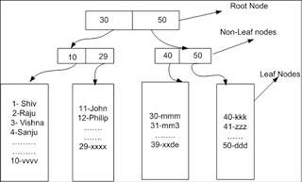](http://3.bp.blogspot.com/-C5O_SOvQqgU/TxfpDc-JWpI/AAAAAAAAD4g/oG92WxL-syQ/s1600/a1.jpg)

CLUSTERED

[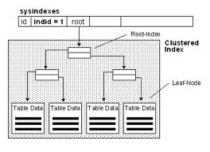](http://www.google.co.in/imgres?imgurl=http://www.akadia.com/img/sqlsrv_clustered_index.gif&imgrefurl=http://www.akadia.com/services/sqlsrv_programming.html&h=302&w=416&sz=6&tbnid=KpMygsDPQvabKM:&tbnh=86&tbnw=118&prev=/search%3Fq%3Dclustered%2Band%2Bnon%2Bclustered%2Bindex%2Bdiagram%26tbm%3Disch%26tbo%3Du&zoom=1&q=clustered+and+non+clustered+index+diagram&usg=__fFV4yrS6-PZiFDmlEKsIWry1HEc=&docid=M6aRf-ZIRWgA-M&sa=X&ei=32clUq-rLsrSrQfJ0oHwBA&ved=0CDsQ9QEwBQ&dur=672)

[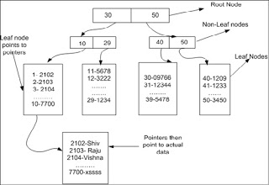](http://4.bp.blogspot.com/-AQX9nZbTbUY/TxfpgUmv0oI/AAAAAAAAD4o/0WnddmPrNH0/s1600/a2.jpg)

NON CLUSTERED

